## horizontal line

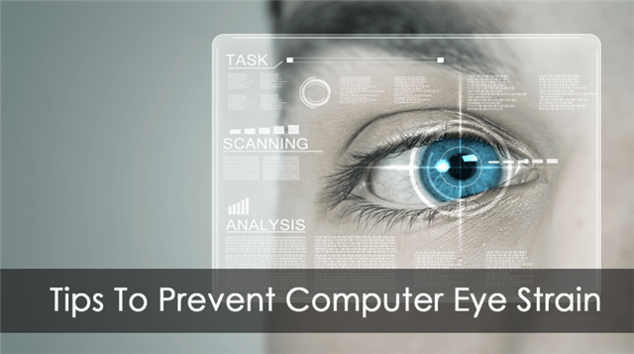

Strain Analysis Based On Eye Blinking

08.11.2020

**─**

Tanya Garg

Pursuing B.Tech (CSE)

Meerut Institute of engineering and Technology

# Overview

A neural network model is built which alerts the user if eyes are getting strained. This model uses the integrated webcam to capture the face (eyes) of the person. It captures the eye movement and counts the number of times a person blinks. If blink count deviates from the average value (if the number of blinks is less or more), then an alert is initiated by playing an audio message along with a popup message is displayed on the screen appropriately.

# Goals

1. know fundamental Computer vision, google text to speech.
2. Gain a broad understanding of face landmark detection.
3. know how to install necessary packages and set up the environment.
4. Calculate Eye aspect ratio
5. Work with google text to speech
6. Work with Tkinter

# Specifications

To create an eye blink detector, eyes will be the area on the face that we are interested in. We can divide the process of developing an eye blink detector into the following steps:

1. Detecting the face in the video
2. Detecting facial landmarks of interest (the eyes)
3. Calculating eye width and height
4. Calculating eye aspect ratio (EAR) – relation between the width and the height of the eye
5. Displaying the eye blink counter in the output video
6. Based on the blinks, an alert is initiated to the user with an audio message and popup message.

# Project Report

Tsk 572 (Importing Necessary Libraries)

All the necessary libraries have been successfully imported in the main application file “app_eye.py” . As previously mentioned in the project prerequisites, Jupyter notebook has been used to accomplish this task and later the file has been extracted as a python file with a (.py) extension.

Tsk 573 (Defining Necessary Functions)

All the necessary functions have been successfully defined in the file named “app_eye.py”. The functions are described below,

**a. playaudio(text)**

In this function, we are translating the text input to a speech by using gTTS and saving the translated speech to the output1.mp3 file. We are returning the output1.mp3 to the calling function.

**b. popupmsg(msg)**

* Creating an instance of Tk initializes the interpreter and creates the root window
* Giving a title and style to the popup window and configuring it using the configure function.
* A label is used to display text messages Generally the content is static, but your program can change the text.
* pack() is geometry manager organizes widgets in blocks before placing them in the parent widget.
* We are creating an “Okay” button and showing the window using mainloop() function .

**c. eye_aspect_ratio(eye) :**

We can Calculate Eye Aspect Ration this using the below code

* Compute the Euclidean distances between the two sets of vertical eye landmarks (x, y)-coordinate.
* Compute the Euclidean distance between the horizontal eye landmark (x, y)-coordinates.
* Compute the eye aspect ratio using the above formula and then return ear to the calling function